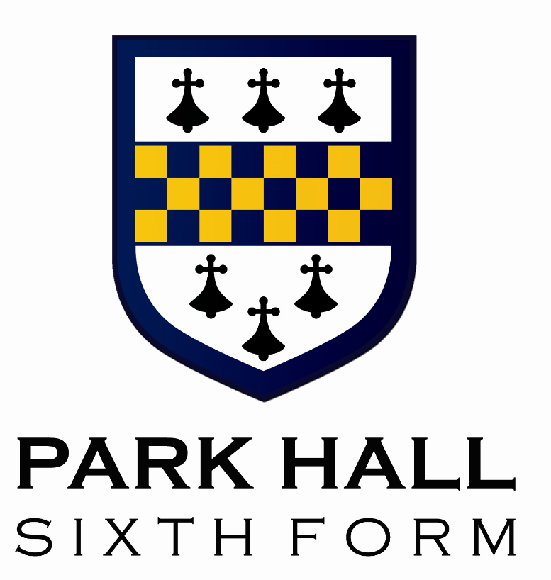
Park Hall Sixth Form
Bursary Policy
2026 - 2027

Park Hall Sixth Form Bursary

The Department for Education has allocated an amount of money to Park Hall to allow the school to grant bursaries to students on low incomes to contribute towards the costs of studying in the Sixth Form.

Eligibility

To be eligible to receive a bursary you must be a full time student at Park Hall Sixth Form and be aged under 19 on 31st August in the academic year in which you begin your programme.

The two levels of payment at Park Hall

Level One

Students who are:

- In care
- A care leaver
- Receiving Income Support or Universal Credit because they are financially supporting themselves and someone who is dependent on them and living with them
- Receiving Disability Living allowance or Personal Independence payments in addition to Employment Support allowance or Universal Credit in their own right

Level Two

Students who are in receipt of free school meals*or with a household income of less than £30,000 per year.

*If a student previously had free school meals, this may indicate eligibility, but the actual financial need will vary depending on personal circumstances. An individual assessment of actual financial needs must be made to determine this.

How the funds will be paid
Those eligible for the bursary, will submit claim forms (forms will be provided) attaching VAT receipts for all expenses/purchases which will then be verified and paid directly into student bank accounts. These can be submitted to the Sixth Form office at any time throughout the academic year not just at the end of the term. Funds will be paid directly into the bank account that you provide in your application form. We recommend that you discuss any potential purchases with Mrs Griffiths or Mr Cornell before committing to buy so we can confirm whether or not they can be funded by the Sixth Form Bursary.

Students who qualify for the Sixth Form Bursary may claim a maximum reimbursement of £80 towards the cost of appropriate business wear in accordance with the Sixth Form Business Dress Code. Bursary funding will only be provided upon submission of valid receipts or other acceptable proof of purchase. All claims must be submitted within 3 months of the original purchase date. Students are advised to confirm with Mrs Griffiths that any intended purchases meet the requirements of the Business Dress Code before making a purchase. The school will not reimburse the cost of items that do not comply with the Business Dress Code.

- Curricular School trips within the UK
- Laptops to support independent study at home (these will be purchased by the school and will remain the property of Park Hall Academy, being returned at the end of a student’s studies).
- School related travel expenses (such as a bus pass)
- School Stationery (Folders, plastic wallets, pens, calculators)
- Educational Text Books/ Course Guides
- Revision Guides and Materials
- UCAS Application Costs

The Process you should follow

If you are eligible for a bursary on any one of the levels, you should apply as soon as possible. All applicants are required to completed the application form and submit evidence that household income is less than £30,000. This evidence may be a P60, letters or emails confirming benefits that you are in receipt of and other evidence of household income. This evidence is a requirement in accordance with Government guidelines for the Bursary Auditors. We would like to strongly encourage any students that feel that they may be eligible to apply. Many of our current students use these funds to purchase personal materials, books and revision guides through the school that greatly support their progress in school.

For more details of the scheme please visit the following web site:
https://www.gov.uk/1619-bursary-fund/overview

Please find our 2026 Park Hall Sixth Form Bursary Application here. Please submit a completed form, along with the required evidence to our Sixth Form Progress Manager Mrs Griffiths either via email at mgriffiths@parkhall.org or via the post to

Mrs M Griffiths
Sixth Form Progress Manager
Park Hall Academy
Water Orton Road
Castle Bromwich
Birmingham
B36 9HF

