Conversion -Decimals/Fractions
Section 1: Converting from fractions to decimals
Key words: Numerator- top number of a fraction Denominator-bottom number of a fraction
A fraction means ‘the top number divided by the bottom number’. The fraction ½ means 1 divided by 2, just like half a pizza is one whole pizza divided into two.
To convert from a fraction to a decimal, we use the bus stop method with the denominator outside, and the numerator inside the bus stop.
Webpage: https://www.bbc.co.uk/bitesize/topics/znmtsbk/articles/z4ymtv4#:~:text=The%20line%20in%20a%20fraction%20that%20separates%20the%20numerator%20and,our%20answer%20as%20a%20decimal.
Model Example :
https://www.khanacademy.org/math/arithmetic/arith-decimals/arith-review-decimals-to-fractions/v/converting-fractions-to-decimals-example
Convert the below fractions to decimals:
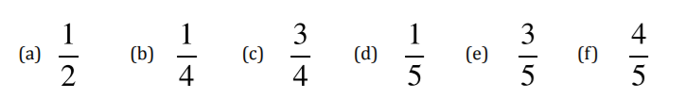
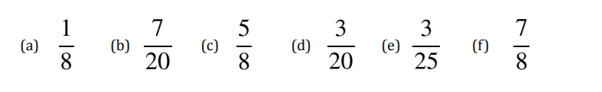
Sometimes, when we do this we get the same number that continues. This is called a recurring decimal.
Try to convert 1/3 to a decimal. What do you notice?
If we get the same number repeated this is a recurring decimal we write this as $0.\dot{3}$ with the dot above the number that repeats.

Convert the below fractions to recurring decimals:
