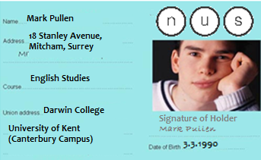Bank Receipt

Bank Account No: 94813

Name of Account:  
Mark Pullen

Amount remaining in your Account on:   
June 8th

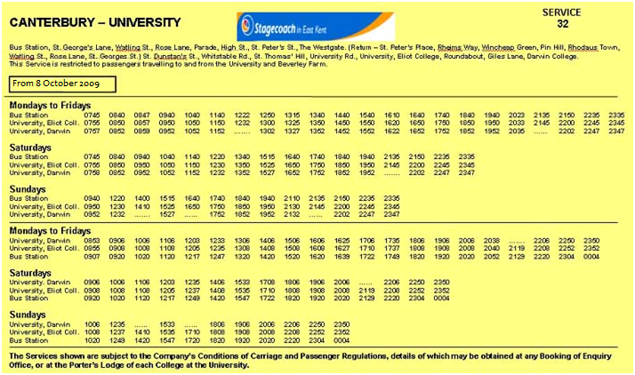is: £3.64





|  |  |  |  |
| --- | --- | --- | --- |
| **YOUR DENTAL APPOINTMENT** | | | |
|  | | | |
|  | DAY | DATE | TIME |
| 1 | Friday | 8th June | 9.15 a.m. |
| 2 |  |  |  |
| 3 |  |  |  |
| 4 |  |  |  |
| I f unable to attend, an early cancellation of appointment is necessary, otherwise a charge will be made. | | | |

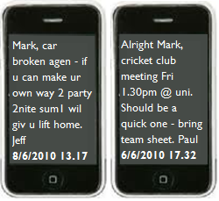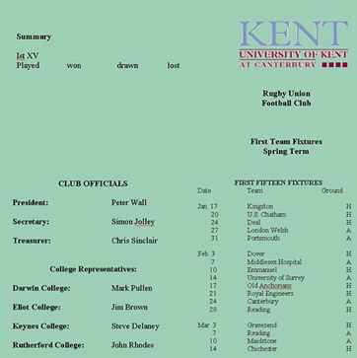

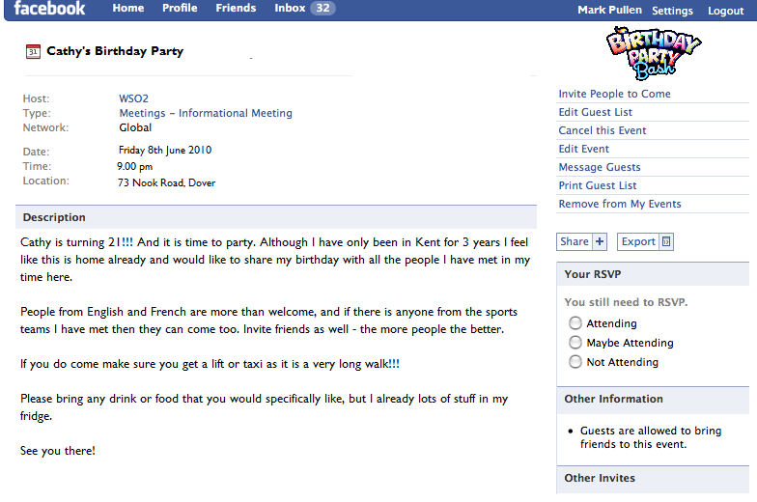

**Class Dates** Summer Term 2010 **English Dept** Plays of Shakespeare **Room H22** 2.30pm – 4.30pm

Our classes will be on the following dates: 27th Apr, 4th May, 11th May, 18th May, 25th May, 1st June, 8th June, 15th June

JPR Craig – Head of English