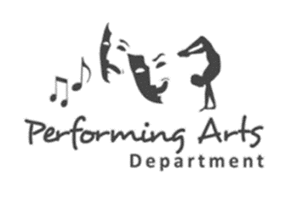
Year 6 Performing Arts EXPLORING THE WORLD OF THEATRE
NAME ____________________________
Key words about The World of Theatre
Task 1: Complete this grid
Key word | Heard before? | Meaning
Theatre
Stage
Costume
Audience
Auditorium
Character
Performance

Task 2: Read this short script taken from ‘The Chamber of Secrets’
Setting: The students are in their charm class; they have to use a spell to make feathers levitate. Ron and Hermione are working as a pair
Ron: We need to figure out how to do this! Whenever we try it, it nothing works!
Hermione: Well it’s obviously, because you’re not saying it properly!
Ron :( sarcastically) why don’t you try it, Miss.Granger.
Hermione :( spitefully) No. I’m researching on the spell, why don’t you try Mr.Weasley!
Ron: Wingardium Leviosa!
The feather doesn’t move an inch from the table.
Hermione: You said it wrong! It isn’t Wingardia Leviosaaaa! It’s
Wingardia Leviosa!
Slowly the feather lifted off the table; it glides around the room.
Hermione is very pleased with her and then grins at Ron.
Ron: It was only a onetime thing; you won’t be able to do it again!
(Ron grunts)
Hermione: What? Are you jealous? (Hermione laughs at Ron)
Ron :( sarcastically) Ha-ha so funny!
Ron tries again
Ron: Wingardia Leviosaa!(The feather just lies there)WHY ISN’T IT WORKING!
Hermione: I told you, you’re not saying it correctly
Ron: Ugh! You’re always correcting me!
Hermione: I was just trying to
Ron: WINGARDIA LEVIOSA!
The feather instantly zooms into the air, Hermione and Harry gasp in surprise.
Ron: I told you I could do it!
Hermione: No Comment!
Hermione: You didn’t say it correctly, although you showed you could handle this spell, you need to say it like a TRUE wizard!
Ron: That doesn’t matter!

Task 3: Design a costume for a character from Harry Potter

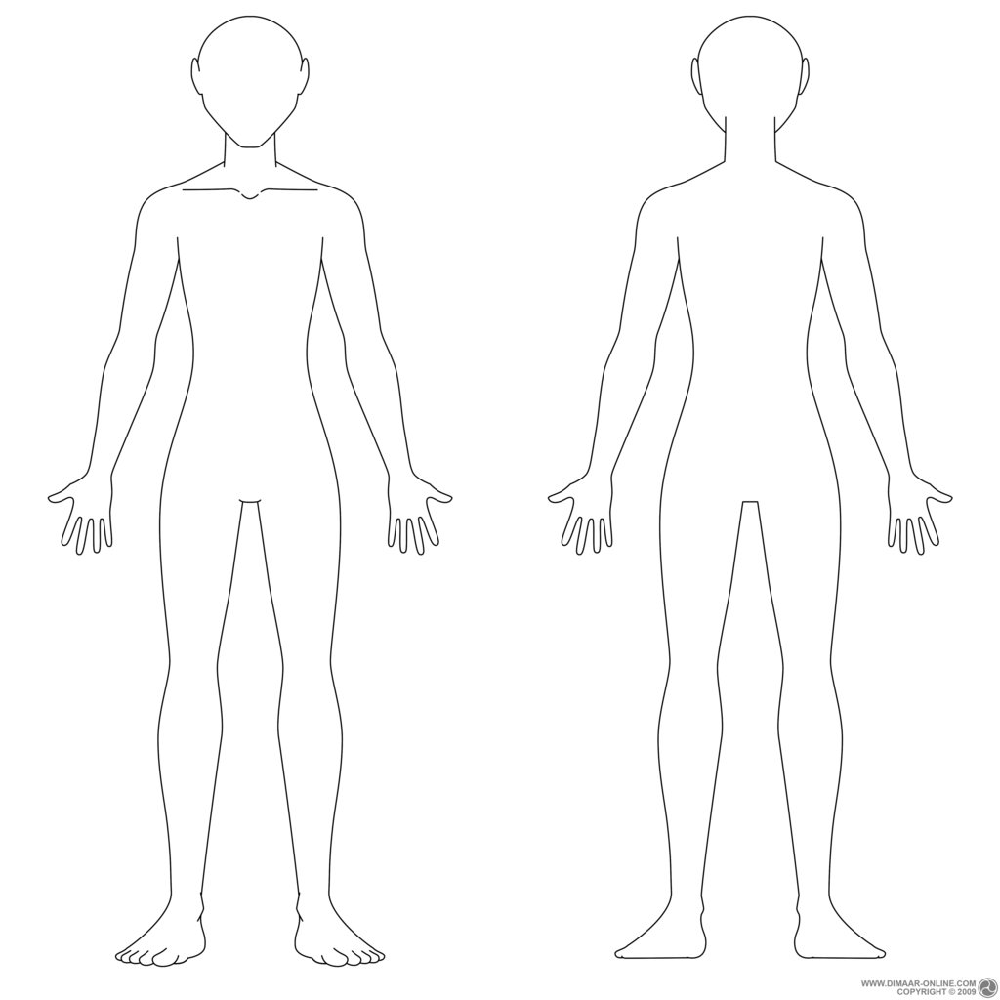

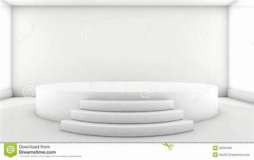
Task 4: Design the set here that your short performance will take part in.

