Compound Shapes
Compound shapes are two shapes combined. To find the areas of these you split them into two, find the areas of each, then add them together.
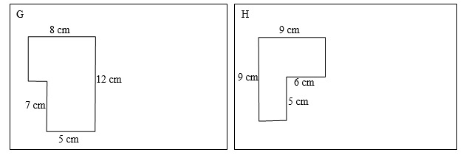
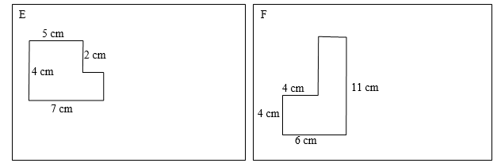
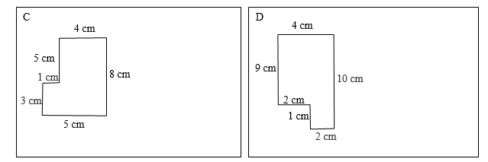
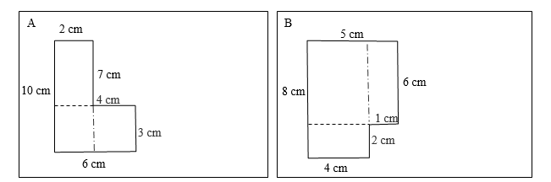
https://owlcation.com/stem/Compound-shapes-How-to-find-the-area-of-a-L-shape

